AN UN-BAKE SALE!

We will have healthy holiday treats for sale after the workshop, bring your dollars and invest in your yummy good health!

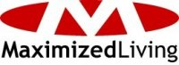

Each registered participant will receive a complimentary workshop packet full of nutritional facts and delicious healthy recipes.

This is a ***free*** workshop for you!

We will be serving cold pressed coffee and a raw food snack before the workshop.



Sponsored by and located at 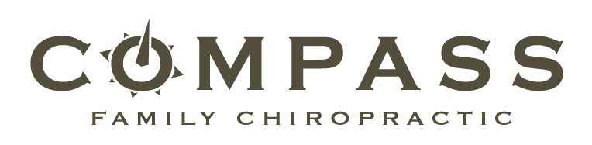

10451 Garverdale Ct. Ste.204, Boise, ID 83704

To register Contact:

Dr. Jake Erickson via:

* Phone: 208-914-0182 * Email: Erickson.jake@gmail.com:

* Twitter: DrJakeCFC * Face to Face ☺

Saturday December 12th, 2009 10am - Noon



Nutrition and Raw Foods

A Wellness Warrior Workshop